FIF8a Feature of Parabolas

For the following expressions find the factored form, expanded form, x-intercepts, y-intercept, line of symmetry, and vertex. Remember to show all work.
- $y=27x^{2}+12x-4$
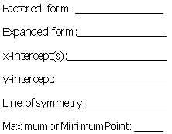

- $y=\left(x+5\right)\left(x-8\right)$
- $y=x\left(x+2\right)$

- $y=2x^{2}+12x+16$

- $y=\left(x+3\right)\left(x-1\right)$
- $y=x^{2}-13x+40$
- $y=3x^{2}+16x-35$

