Samples and Populations Unit Test REVIEW 2016
Standards
7.SP.1: Understand that statistics can be used to gain information about a population by examining a sample of the population; generalizations about a population from a sample are valid only if the sample is representative of that population. Understand that random sampling tends to produce representative samples and support valid inferences.
7.SP.2: Use data from a random sample to draw inferences about a population with an unknown characteristic of interest. Generate multiple samples (or simulated samples) of the same size to gauge the variation in estimates or predictions.
7.SP.3: Informally assess the degree of visual overlap of two numerical data distributions with similar variabilities, measuring the difference between the centers by expressing it as a multiple of a measure of variability.
7.SP.4: Use measures of center and measures of variability for numerical data from random samples to draw informal comparative inferences about two populations.

7.SP.1 Practice
- David wants to estimate the number of students from his seventh grade class whose favorite subject is math. He needs to create a random sample of students. How should David collect his sample data? Explain why this is the best option.

- David should ask 20 students in a math class.

- David should ask 20 students on a school bus.

- David should ask 20 students in seventh grade.

- David should ask 20 students from the entire school.

- The principal wants to send ten students to represent the school at a state conference. She makes an announcement about the conference. She decides to send the first ten students who contact her after the announcement. Which sampling method did the principal use? Explain your answer.

- convenience sampling
- voluntary-response sampling
- systematic sampling
- random sampling

  - The principal wants the group to be representative of the school population. Is the principal’s method of selecting students a good method? Explain your reasoning. If you think the principal’s method is not adequate, explain how you think the principal should select students.

7.SP.2 Practice
- A representative sample of 50 students from a high school is surveyed. Each student is asked what science class he or she is taking. The table shows the responses.
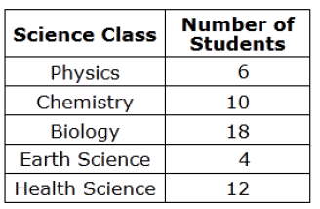

Select all the statements about the students at the high school that are valid based on the survey results. Show your thinking for how you determined your correct answers.

Statements | Why is the valid/not valid?
A. Twice as many students are taking Health Science than are taking Physics.

B. 20% of students are taking Chemistry.

C. In a group of 25 students, it is expected that 4 of the students are taking Earth Science.

D. In a group of 150 students, it is expected that 18 of the students are taking Physics.

7.SP.3 Practice
The box plot shows a summary of test scores for Class A and Class B on the same exam. Both classes have the same number of students. Use this box plot to answer questions 4 and 5 on the following page.
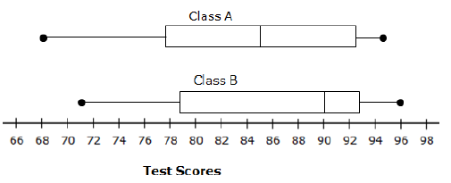

- Determine whether each statement is true based on these box plots. Select True or False for each statement.
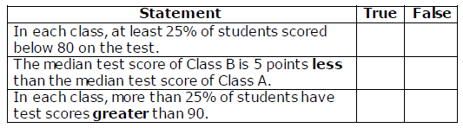

- Class B has higher scores for each of the 5 Number Summaries, but overall, the scores appear to only be slightly higher. Using the box plot, make an argument as to why Class B was indeed more successful than Class A.

7.SP.4 Practice

These dot plots show the number of daily text messages sent by two different groups of students.

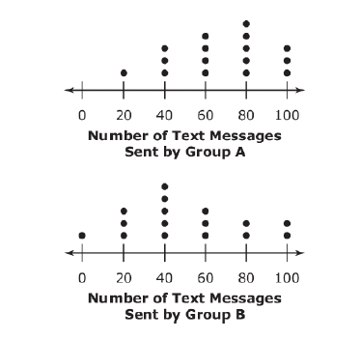

- How many students in Group B sent fewer text messages than the mean number of text messages sent by Group A?

- How much greater is the mean number of text messages sent by Group A than the mean number of text messages sent by Group B?

- How much greater is the median number of text messages sent by Group A than the median number of text messages sent by Group B?

- What is the difference between the mean absolute deviation of the number of text messages sent by the two groups?

- These box-and-whisker plots show the price per square inch of pizza for each size. Which size appears to be the best buy? Explain your reasoning.

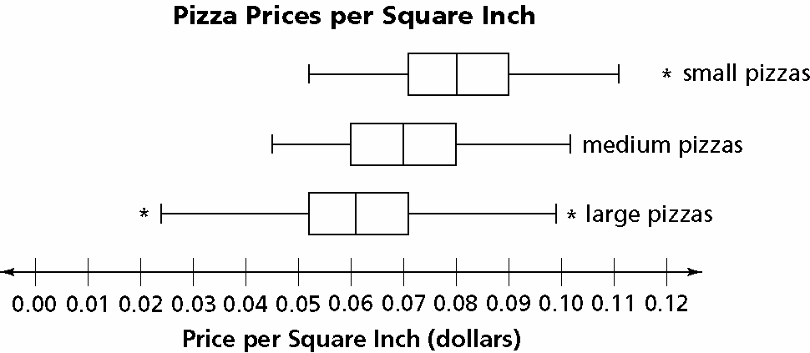

Below are the ages of 20 players from each of two baseball teams.

Splashing Orcas
30 | 30 | 24 | 21 | 27 | 35 | 31 | 26 | 26 | 31
32 | 32 | 27 | 25 | 26 | 31 | 32 | 29 | 28 | 25

Fighting Narwhals
30 | 29 | 40 | 26 | 28 | 32 | 29 | 29 | 29 | 31
38 | 36 | 31 | 34 | 25 | 29 | 35 | 38 | 30 | 34

a. Fill in the table below to compare the ages of the teams.

 | Splashing Orcas | Fighting Narwhals
Mean
MAD
Median
IQR
Range

b. Use the table from part (a). Which team is older? Justify your answer.

