Tri 3 Review Last Day

1. Reflect the figure below across the line  
     
   
2. Rotate the figure below 70 counter clockwise around point B  
     
     
     
   
3. Translate the figure below the angle and distance indicated by the arrow  
     
     
   

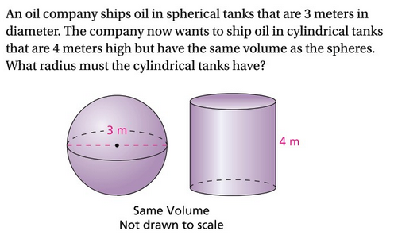

1. Identify the angle relationships and then solve for x.

|  |  |  |
| --- | --- | --- |
|  |  |  |
|  |  |  |
|  |  |  |

1. Identify if each figure below is similar, congruent, or neither. If similar or congruent identify the transformations. If neither explain why.  
     
     
     
     
     
     
     
   

|  |  |
| --- | --- |
|  |  |
|  |  |
|  |  |
|  |  |