Reflection and Rotation Practice

- Show work for finding the line of symmetry for the figures below:
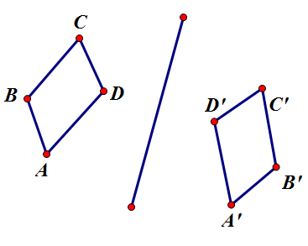

- Reflect the image below across line z.
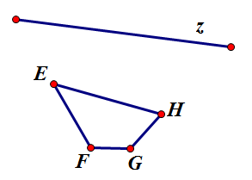

Rotate 120 degrees counter clockwise around point P

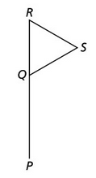

Rotate 90 degrees around point Q

