8.G.1 Practice

Rotate the figure below counter clockwise 125 degrees around point C.  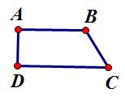 | Translate the figure below 2.5 cm at 300 degrees.
Reflect the figure below across the line.
