CC8 – Algebra Name _______________________
Translating and Reflecting Graphs Date ___________ Period ___

1. Describe each graph as a transformation of y = $\left|x\right|$ or y = x². Then write its equation.
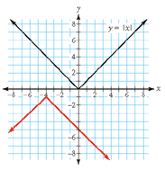
Example: Answer: Reflect the graph y = $\left|x\right|$ across the x-axis. Then, translate
4 units to the left and 1 unit down.

Equation: y = $-\left|x+4\right|-1$

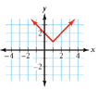
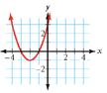
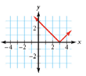
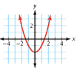
a. b. c. d.

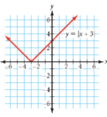
2. Describe each graph below as a transformation of y = $\left|x+3\right|$, shown at the right.
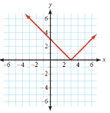
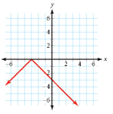
- b.

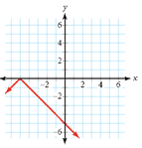
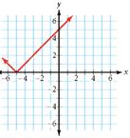
c. d.

3. Write an equation for each transformation of the given parent function.

a. Transform the parent function $y= \left|x\right|$ by translating it to the left 5 and up 7 units.

b. Transform the parent function y = x² by translating it to the right 6 and then reflecting it across the x-axis.

c. Transform the parent function y = x² moving it down 3 units and to the left 10 units.

d. Transform the parent function $y= \left|x\right|$ by moving it down 2 units and reflecting it across the x-axis.

e. Transform the parent function $y= \left|x\right|$ by reflecting it across the x-axis, moving it to right 7 units and down 1
unit.

4. Describe how each equation transforms the parent graph y = x² or y = $\left|x\right|$.

a. y = (x + 3)² b. y = $\left|x-1.5\right|$ c. y = -x² – 5

d. y = (x – 2)² + 13 e. y = -$\left|x+9\right|-8$ f. y + 2.5 = $\left|x-4\right|$.

5. Use f(x) = 2$\left|x+4\right|$ + 1 to find the following:

a. f(5) b. f(-6) c. f(-2) + 3 d. f(x + 2)

6. A chemical reaction consumes 12% of the reactant per minute. A scientist begins with 500 grams of one
reactant. So, the equation y = 500 (0.88)^{x} gives the amount of reactant, y, remaining after x minutes.

- What does the number 0.88 tell you? b. What does the number 500 tell you?

c. How much reactant is remaining after 5 minutes?

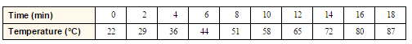
7. This table shows the temperature
of water in a pan set on a stove.

- Find the equation of a line that models this data.

- How long will it take for the water to boil (100°C)?

